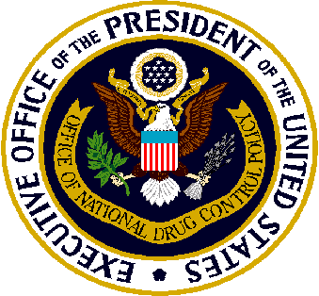

High Intensity Drug Trafficking Areas (HIDTA)
Checklist for Petitions for Designation
Background: Petitions for HIDTA designation must be submitted to the Office of National Drug Control Policy by a coalition of law enforcement agencies from the geographic area seeking designation. Typically, representatives of this coalition work closely with the Director of the HIDTA that these areas, if designated, would join.
To be considered for designation, petitions should meet all of the following criteria:
- Be submitted at least 10 business days before the independent panel convenes.
- Specify the geographic area for which HIDTA designation is being sought. (Areas typically are designated by county and/or city.)
- Include individual and separate submissions for each geographic area for which HIDTA designation is sought. (For example, if designation is sought for multiple adjacent counties, a separate petition must be submitted for each county.)
- Include an assessment of the threat posed by illicit drugs in the area. Specifically, the assessment must provide evidence that explicitly addresses each of the following four points:
  - The area is a significant center of illegal drug production, manufacturing, importation, or distribution;
  - State, local, and tribal law enforcement agencies have committed resources to respond to the drug trafficking problem in the area, thereby indicating a determination to respond aggressively to the problem;
  - Drug-related activities in the area are having a significant, harmful impact in the area and in other areas of the United States; and
  - A significant increase in Federal resources is necessary to respond adequately to drug-related activities in the area.
- Receive the approval of the Executive Board of the regional HIDTA program to which, if the petition is successful, the area would be added. This approval should be indicated in writing by including a letter with the petition signed by the chair of the Executive Board.
- Be submitted to ONDCP via e-mail to ONDCP_HIDTA@ondcp.eop.gov .
Next Steps: Within 5 business days of submission, ONDCP will review and acknowledge receipt of the petition. At this point, ONDCP will also alert the respective HIDTA if any parts of the petition are missing or if any of the criteria stated above are not met. (Please note that incomplete petitions will not be reviewed by the independent panel. If it is necessary to resubmit a petition, it must be received at least 10 business days before the independent panel convenes.) Prior to the convening of the independent panel, the National HIDTA Director will send a letter to the HIDTA Director formally acknowledging receipt of the complete petition.

April 18, 2018

